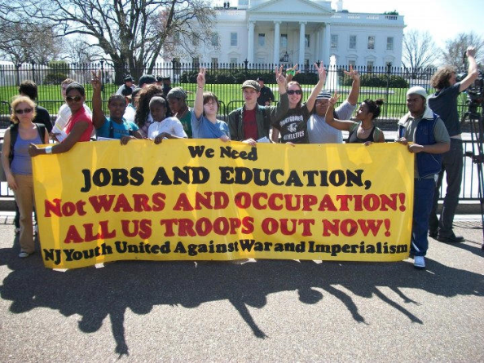
Youth Organizing: We Are Looking for Partners
Throughout the world, young people are beginning to fulfill their role in history as change catalysts. Many young people want to help bring about the needed changes, but we need help from activists and their organizations. NJ Youth United Against War and Imperialism wants to partner with you toward these goals:
Promotion of anti-war and anti-imperialism into the political work of youth activists including defenders of public education, tuition opponents, anti-racism, immigrant rights, equality, environmentalism, etc.
Development of youth section, youth organizing projects and activities by all activist groups devoted to identifying constituency, outreach, events, films, discussions, concerts, socials, music jams, etc. Working with you, other activists in your community and your organizations to develop a youth organizing plan in your communities, schools and streets. Development of support between activist youths, youth organizations and other activists and allies.
Youth have much to offer but we need help getting things started. If you want to work with us to develop a plan for organizing youth into our struggles, please contact NJ Youth United Against War and Imperialism, c/o Rob C-Dub, piano_playuh@yahoo.com / http://rawmachine.org/NJYUAWI.htm/ 908-635-3285

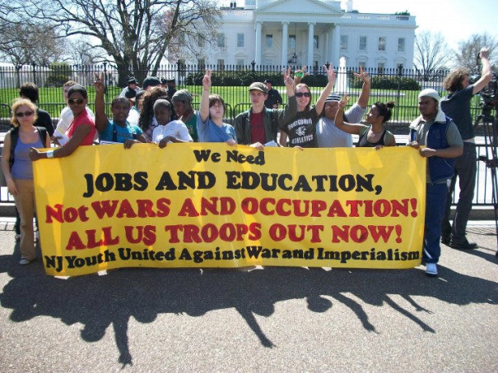
Youth Organizing: We Are Looking for Partners
Throughout the world, young people are beginning to fulfill their role in history as change catalysts. Many young people want to help bring about the needed changes, but we need help from activists and their organizations. NJ Youth United Against War and Imperialism wants to partner with you toward these goals:
Promotion of anti-war and anti-imperialism into the political work of youth activists including defenders of public education, tuition opponents, anti-racism, immigrant rights, equality, environmentalism, etc.
Development of youth section, youth organizing projects and activities by all activist groups devoted to identifying constituency, outreach, events, films, discussions, concerts, socials, music jams, etc. Working with you, other activists in your community and your organizations to develop a youth organizing plan in your communities, schools and streets. Development of supportbetween activist youths, youth organizations and other activists and allies.
Youth have much to offer but we need help getting things started. If you want to work with us to develop a plan for organizing youth into our struggles, please contact NJ Youth United Against War and Imperialism, c/o Rob C-Dub, piano_playuh@yahoo.com / http://rawmachine.org/NJYUAWI.htm/ 908-635-3285

