Welcome to the first issue of YO! The Youth Organizer.
This will be an occasional newsletter of the NJ Youth Against War and Imperialism (see reverse side). The goal is to get this newsletter out among high school, middle school and college students and other youth and to establish a means for us to organize to deal with the many issues we are facing like war, education cutbacks, tuition hikes, attacks on immigrant youth, youth joblessness, and other issues we face as the future closes in on us. We hope you find the information we provide useful and look forward to future discussion and reflective action with you around these and other issues.
War is a Lie – Youth Study Group is Formed
We have obtained 10 copies of the book War Is A Lie by David Swanson. We can share a copy of the book with you for $10. You can also obtain your own directly from David at http://davidswanson.org/warisalie .
The way the group will work is that we will read about a chapter of the book every two weeks or so. We will have study and discussion guide questions. Members of the group should keep up with the reading assignments.
Members should write in the discussion and on the wall of the group at least once a week. Also, members should take action around what we learn from the book.
Hopefully we will meet monthly for discussion, socializing, music, banner making and action planning.
The group is starting in Montgomery Township NJ but we encourage those outside our area to participate in the group discussions.
We are also inviting David Swanson, the book author to be part of the group and hope that he can participate.
On Facebook, you can join at this link: http://www.facebook.com/home.php?sk=group_130709516988196 (or search for “War Is A Lie - Youth Study Group”).
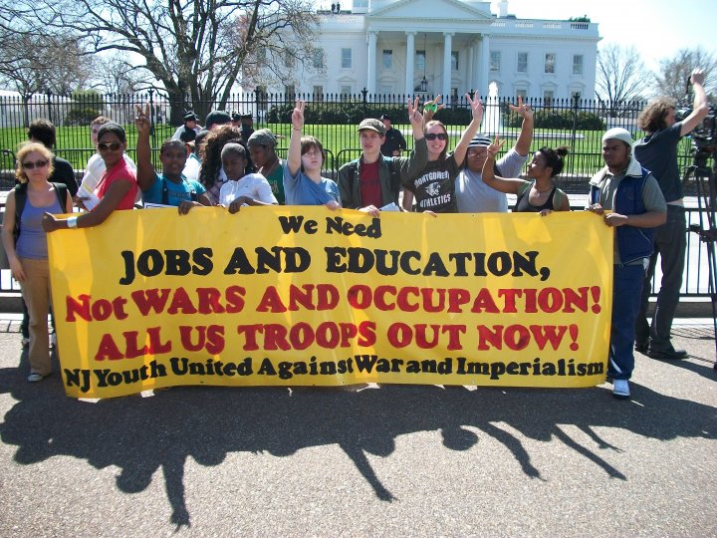
You can also call Rob at 908-635-3285 for the details or to get a book.
We Want You to Join
NJ Youth United Against War and Imperialism
We have grown out of struggle against war and cuts to education in New Jersey. We formed at a banner making party on March 6, 2010.
Goals:
Educate youth about war and its impact on its victims, including those being killed and the youthful soldiers being ordered into combat. We will organize educational meetings, leaflet distribution, music and theatrical presentations and other means of communication and dialogue. We also will educate around the issues of how a war-based economy contributes to joblessness, homelessness, inadequate education and other economic crises domestically.
Attempt to shake our generation out of its disregard for the realities we are facing and redirect it to an active, caring force united and working toward an end to the wars and a reordering of priorities so that human needs are met instead.
Provide a means of communication into all of the high schools and colleges and to youth who are not in school in all of the cities and towns of New Jersey.
Connect youth up to other organizations that are struggling around these issues.
Mobilize youth to participate in every aspect of planning through participation in actions toward these goals, be they standing on a corner with our banner and passing out fliers, to helping to arrange buses to national marches, to supporting national days of action for education and other important issues as well as social events like concerts, picnics, bashes and other fun ways to unify into a stronger force.
Make youth a vital part of a mass movement aiming to make changes around these issues of concern.
Why are we against war and imperialism?
Simply put, imperialism is the system powerful nations like the United States use to control other weaker nations. Imperialism pursues the goals of maximized profit for multinational corporations as well as exerting strategic and military muscle into other regions of the world. War and occupation are the most extreme methods of imperialism. Other means could include economic and political manipulation, threats, secret and not so secret involvement in affairs of other countries, sabotage, assassination, support for insurgent groups with weapons, training and intelligence, blockades and sanctions and many other forms of interference. If we want to prevent wars from occurring, we need to challenge the system of imperialism which is constantly laying the groundwork for future wars.
We want YOU to be part of our organization and our movement to transform the youth into a force of history that will play the role that it should in opposing war and imperialism and supporting a system that meets the needs of all people, with justice and equality. Contact us: 908-881-5275 / piano_playuh@yahoo.com / http://RAWMachine.org/NJYUAWI.htm

