AUDIFY NEW BRUNSWICK!
Songs of Struggle on the New Brunswick Streets! Everybody is IN THE BAND! Bring your instruments, your voice, your hands for clapping and your feet for stomping. Or come to listen. Use our performance for a backdrop for petitioning, leaflet distribution and talking up struggle for change.
Next Performance:
Saturday, April 7, 2-5pm, Livingston and George St.
Songs will be dedicated to the Martyrs and the Captives!
Justice for Trayvon Martin and Barry DeLoatch / Freedom for Jordana
End Mass Incarceration
Some song suggestions include:
El Pueblo Unido Jamas Sera Vencido (dedicated to martyrs of Chile), Blessed Are Those Who Struggle, Strange Fruit, Four Dead in Ohio, Deportees, Que Queremos (Outernational)
Please spread the word to musicians and listeners - young and old!
All genres of music welcome!
New song suggestions encouraged . . . this is peoples music, we are a street orchestra . . . and we are going to fuel the people's movement with sounds that demand change, unity, action, struggle . . .
Musicians - please contact us as soon as possible - especially if you have songs you want us to work on!
908-635-3285 njyu@njyouthunited.org
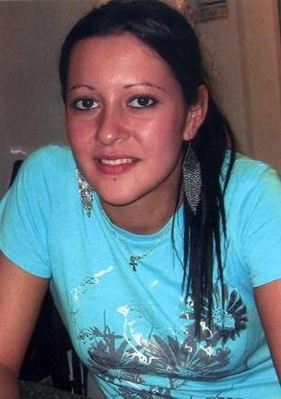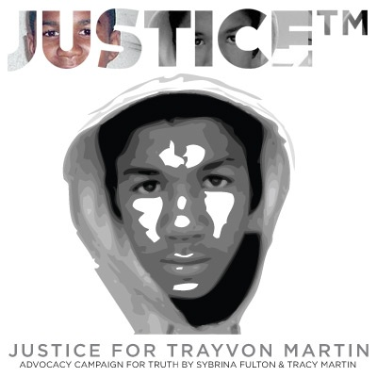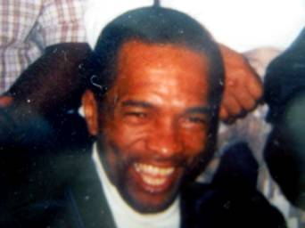
Free Jordana from ICE and end deportations! Justice for Trayvon! Justice for Barry Deloatch!
End Mass Incarceration of Youth!
NJ Youth United Against War and Imperialism http://NJYouthUnited.org

